**BALLAST WATER MANAGEMENT ORGANIZATION (Ship Specific)**

The Purpose of this Form is together with the procedures [EMM](http://srv-glas301:82/Leisure/content/parent%20category%20topics/procedures%20and%20operations/emm.htm) > 2.0 Ballast Water Management Plan to constitute a Ship Specific Ballast Water Management Plan.

This form should be used whenever the vessel does not have a Ballast Water management Plan already approved by Class.

The following parts will be customized as applicable for each vessel in order to make the plan ship specific.

**Ship’s particulars**

|  |  |
| --- | --- |
| Ship Data | |
| Ship’s Name |  |
| Ship type |  |
| IMO no. |  |
| Classification Society |  |
| Registration no. |  |
| Class Notation: |  |
| Call Sign |  |
| Flag |  |
| Port of Registry |  |
| Owner |  |
| Building Yard |  |
| Hull no |  |
| Keel laying date |  |
| Main Dimensions | |
| Length overall |  |
| Length b. perpendiculars |  |
| Breadth |  |
| Depth to main deck (mld) Deck 3 |  |
| Light Ship Draft |  |
| Summer draft |  |
| Deepest ballast drafts (normal and heavy weather) |  |
| Ballast Water Capacity | |
| Total ballast water capacity |  |
| Number of segregated ballast water tanks |  |
| Number of others tanks used for ballast |  |
| Number of ballast water pumps |  |
| Capacity of ballast water pumps (each) |  |
| Description of the main ballast water management method used |  |
| Designated Ballast water management Officer | STAFF CAPTAIN |
| Tonnage measurement | |
| Deadweight |  |
| Gross Tonnage |  |
| Net Tonnage |  |

**Ballast Exchange Methods:**

The applicable method(s) for this ship is:

* The Sequential Method

The sequential method is a process by which a ballast tank is first emptied and then refilled with replacement water to achieve at least 95% volumetric exchange. For this method each ballast tank should be discharged until suction is lost and stripping pumps or eductors should be used if possible.

**The ship has Stability Programme Software:**

Type, name, version :

Approved (Yes, No)

If yes, by which authority

Dedicated computer available (if yes, if type approved)

**The ships is enrolled with an Emergency Response Service for damaged Stability:**

Yes, No

Name of Organization:

**Under/Over pressurizing tank precautions:**

If the system is designed for TWO simultaneous means for filling/emptying: pumps or a pump and an ejector can be used simultaneously for pumping in or out ballast tanks (Yes or No) [normally No]

**Ship Specific Ballasting Instructions:**

Max Number of tanks used at a time

Any Specific Sequence (ie fwd to aft or other)

Free surface effects (tanks with largest FSE)

Any other ship specific instruction (ie max density of ballast etc)

**Limiting Ship Condition Criteria, as applicable:**

Minimum forward draft to Length between perpendiculars ratio: T fwd min/Lbp in % or in meters

Propeller immersion I/D ratio calculation in %: I= distance of propeller’s centreline to the water level, D= propeller’s diameter or in meters

Min or Max trim, by stern or by head

Min visibility from Bridge [“The view of the sea surface from the conning position should not be obscured by more than two ship lengths, or 500 metres, whichever is less, forward of the bow…”] in worst condition

**Onboard Sampling points and locations (as applicable):**

|  |  |  |  |  |  |  |  |  |  |
| --- | --- | --- | --- | --- | --- | --- | --- | --- | --- |
| TK | Sounding pipes location  ((-) to port, (+) to stbd) | | | | Air Vent Pipes | | Manholes | | |
| type | x (a.p.) m | Fr. | y (c.l.) m | Dk | Fr. | side | Fr. | Dk | y (c.l.)  m |
|  |  |  |  |  |  |  |  |  |  |
|  |  |  |  |  |  |  |  |  |  |
|  |  |  |  |  |  |  |  |  |  |
|  |  |  |  |  |  |  |  |  |  |
|  |  |  |  |  |  |  |  |  |  |
|  |  |  |  |  |  |  |  |  |  |
|  |  |  |  |  |  |  |  |  |  |
|  |  |  |  |  |  |  |  |  |  |
|  |  |  |  |  |  |  |  |  |  |
|  |  |  |  |  |  |  |  |  |  |
|  |  |  |  |  |  |  |  |  |  |
|  |  |  |  |  |  |  |  |  |  |
| Ballast  Pump(s) |  |  |  |  |  |  |  |  |  |
| Ballast  Pump(s) |  |  |  |  |  |  |  |  |  |

**Ballast Water System Arrangements**

System Description and Operation

Tank arrangement and capacities

|  |  |  |  |  |
| --- | --- | --- | --- | --- |
| Tk number | Designation | Location | | Capacity  m3 |
| Aft | Fore |
| Operational Ballast | | | | |
|  |  |  |  |  |
|  |  |  |  |  |
|  |  |  |  |  |
|  |  |  |  |  |
|  |  |  |  |  |
|  |  |  |  |  |
|  |  |  |  |  |
|  |  |  |  |  |
|  |  |  |  |  |
|  |  |  |  |  |
|  |  |  |  |  |
|  |  |  |  |  |
|  |  |  |  |  |
|  |  |  |  |  |
| Total Water Ballast Capacity | | | |  |

Piping and pumping arrangement

|  |  |  |  |
| --- | --- | --- | --- |
| Device | Name | Capacity m3/h | Total Head, bar |
| Ballast Ejector(s) |  |  |  |
| Ballast Pump(s) with priming system |  |  |  |
| Ballast Pump with priming system |  |  |  |
| GS Pump(s) |  |  |  |

Possibility to discharge ballast water to reception facilities:

**Typical Loading Condition for Ballast Water Exchange.**

For this specific passenger vessel, a typical loading condition (utilizing maximum ballast intake) from the Stability Booklet (Software) (with any modifications if needed) will be checked for compliance with all relevant criteria and limitations and the estimated time span for exchange calculated.

Beginning from fore to aft, in a step-by-step procedure each loaded ballast tank will be investigated for exchange via the sequential method.

Stores onboard upon completion of the exchange should be sufficient to arrive safely in a port if assuming the exchange will be completed more than 200 nm from shore

**All the intermediate results for this typical condition will be calculated and recorded for this vessel in the SMS form SAF42 “Ballast water Exchange Plan” which will be attached to this BWMP**

For clarity, an example of selecting such a typical ballast exchange condition and the required calculations is herewith shown:

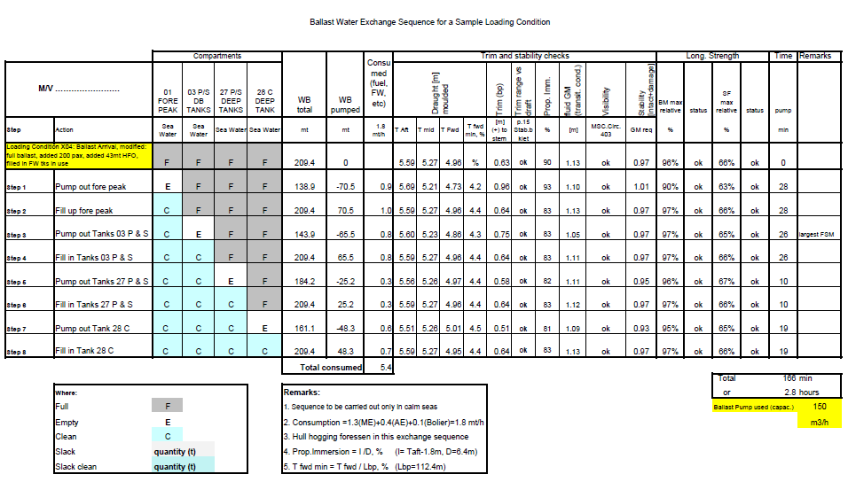

**Ship Specific Ballast Water Training**

Under the authority of the Master, the Staff Captain is delegated to provide training to all crewmembers involved in ballast water exchanges.

The training will cover ship’s officers and ratings engaged in ballast water management. They will be trained once upon joining the ship and later if any of the elements below have changed.

the ship’s ballast pumping arrangements

positions of associated air and sounding pipes

position of all tank suctions and pipelines connecting them to the ballast pumps

the method of ensuring that sounding pipes are clear and that air-pipes and their non-return devices are in good order

the different times required to undertake the various ballast water exchange operations

the methods in use for ballast water exchange at sea if applicable with particular reference to safety precautions

the method of on-board ballast water record keeping, reporting and recording of soundings

the need to continually monitor ballast water exchange operations

Training Records with names and ranks and the date the training has been carried out will be maintained as per the form below:

| **Name** | **Rank / Title** | **Date** | **Signature** | |
| --- | --- | --- | --- | --- |
| **Crew** | **Trainer** |
|  |  |  |  |  |
|  |  |  |  |  |
|  |  |  |  |  |
|  |  |  |  |  |
|  |  |  |  |  |
|  |  |  |  |  |
|  |  |  |  |  |
|  |  |  |  |  |
|  |  |  |  |  |
|  |  |  |  |  |
|  |  |  |  |  |
|  |  |  |  |  |
|  |  |  |  |  |
|  |  |  |  |  |
|  |  |  |  |  |

**Summary of Existing and Proposed Ballast Water Legislation**

This will be periodically updated by the Company via a Bulletin Letter which will be used in conjunction with this Plan.